**Bỏ màn chọn kho và màn chọn phiếu nhập xuất, thay màn chọn phiếu bằng màn scan mã phiếu, sau đó gọi API lấy thông tin ngày + kho để fill vào 2 trường bên dưới:**

**Mô tả chung Màn hình Scan lấy mã đơn:**

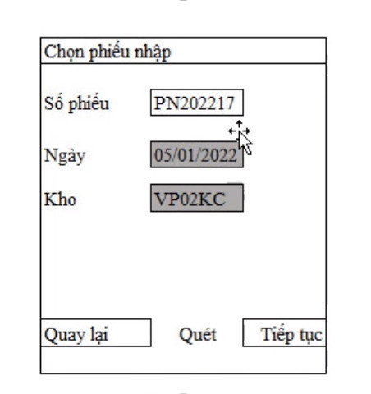

|  |  |  |
| --- | --- | --- |
| **Fiels** | **Nhập** | **Xuất** |
| Số phiếu | PurchaseOrderNo | SaleOrderNo |
| Ngày | PurchaseOrderDate | SaleOrderDate |
| Kho | WarehouseCode | WarehouseCode |

**MÀN HÌNH NHẬP KHO**

- API: api-ht/saleorders/getsaleorderscan

- input:

{

  "BarcodeScan": "1234567876"

}

- outPut:

{

    "Message": "Lấy dữ liệu thành công",

    "RespondCode": **null**,

    "ErrorCode": "0",

    "data": [

        {

            "ID": 7,

            "PurchaseOrderNo": "167890875577",

            "PurchaseOrderDate": "2022-01-01T00:00:00",

            "WarehouseCode": "KAMIS1",

            "WarehouseName": "Hà nội",

            "ExportStatus": "N",

            "InputStatus": "1",

            "PrintStatus": "N",

            "GetDataStatus": "N",

            "RecordStatus": "N",

            "CreateDate": "2022-01-01T00:00:00",

            "UserCreate": "giangapao1",

            "UserUpdate": **null**,

            "UpdateDate": **null**

        }

    ]

}

**MÀN HÌNH XUẤT KHO**

- API: api-ht/purchaseorder/getpurchaseorderscan

- input:

{

  "BarcodeScan": "1234567876"

}

- output xuất:

{

    "Message": "Lấy dữ liệu thành công",

    "RespondCode": **null**,

    "ErrorCode": "0",

    "data": [

        {

            "ID": 1,

            "SaleOrderAmisID": 1,

            "SaleOrderNo": "1234567876",

            "CustomerCode": "1",

            "CustomerName": "1",

            "SaleOrderDate": "2022-01-10T00:00:00",

            "WarehouseCode": "KAMIS1",

            "WarehouseName": "Hà nội",

            "ExportStatus": "N",

            "GetDataStatus": "N",

            "RecordStatus": "N",

            "CreateDate": "2022-01-10T00:00:00",

            "UserCreate": "1",

            "UserUpdate": **null**,

            "UpdateDate": **null**

        }

    ]

}

Data: theo model cũ của màn nhập xuất.

**MÀN HÌNH CHUYỂN KHO**

- API: api-ht/transferinstruction/gettransferinstruction

- input:

{

  "BarcodeScan": "1234567876"

}

- output xuất:

{

    "Message": "Lấy dữ liệu thành công",

    "RespondCode": **null**,

    "ErrorCode": "0",

    "data": [

        {

            "ID": 3,

            "TransferOrderNo": "123",

            "InstructionDate": "2022-01-14T00:00:00",

            "GetDataStatus": "N",

            "TransferStatus": "N",

            "LocationCode_From": "HN",

            "LocationName_From": "Hà Nội",

            "WarehouseCode_From": "1",

            "WarehouseName_From": "1",

            "WarehouseType_From": "1",

            "LocationCode_To": "VP02KC",

            "LocationName_To": "Kho nhà máy 2 tại Vĩnh Phúc",

            "WarehouseCode_To": "2",

            "WarehouseName_To": "2",

            "WarehouseType_To": "2",

            "TransferType": "C",

            "Remark": **null**,

            "RecordStatus": "N",

            "CreateDate": **null**,

            "UserCreate": **null**,

            "UpdateDate": **null**,

            "UserUpdate": **null**,

            "TransferOrderAmisID": 1,

            "OrderNo": "123"

        }

    ]

}

public class TransferInstructionBPLModel

{

public int ID { get; set; }

public Nullable<int> TransferOrderAmisID { get; set; }

public string TransferOrderNo { get; set; }

public string OrderNo { get; set; }

public Nullable<System.DateTime> InstructionDate { get; set; }

public string GetDataStatus { get; set; }

public string TransferStatus { get; set; }

public string LocationCode_From { get; set; }

public string LocationName_From { get; set; }

public string WarehouseCode_From { get; set; }

public string WarehouseName_From { get; set; }

public string WarehouseType_From { get; set; }

public string LocationCode_To { get; set; }

public string LocationName_To { get; set; }

public string WarehouseCode_To { get; set; }

public string WarehouseName_To { get; set; }

public string WarehouseType_To { get; set; }

public string TransferType { get; set; }

public string Remark { get; set; }

public string RecordStatus { get; set; }

public Nullable<System.DateTime> CreateDate { get; set; }

public string UserCreate { get; set; }

public Nullable<System.DateTime> UpdateDate { get; set; }

public string UserUpdate { get; set; }

}